**TIC-TAC TOE GAME:**

**OBJECTIVE:**

This project mainly aims to develop a tic tac toe game using python.

**DESCRIPTION:**

Our project name is Tic tac toe game. This game is very

popular and we all have played in our childhood. It is

actually a two player game. In this game ,there is board

with n*n squares. And in our project , it is 3*3 squares. So,

basically the goal of this is to be one of the players to getthe same symbols in a row - horizontally,vertically or

diagonally on 3*3 grid.

**GAME RULES:**

A player has to choose between two symbols with his

opponent, usual games use ‘X’ and ‘O’. If first

player(Player 1) choose ‘X’ then the second play with ‘O’

and vice versa.A player mark any of the 3*3 square with the symbol that

the player selected and his aim should be to create a

straight line horizontally or vertically or diagonally with

two intentions:

i) Create a straight line before his opponent to win the

game

ii) Restrict his component from creating a straight line.

In case, if both of them fails to create a straight line then

in that case the game will be draw.

If any player is able to draw three X or three O in the

following combinations then that player wins

And the combination are as follows:1. (1,2,3)

2. (4,5,6)

3. (7,8,9)

4. (1,4,7)

5. (2,5,8)

6. (3,6,9)

7. (1,5,9)

8. (3,5,7)

**ARCHITECTURE:**

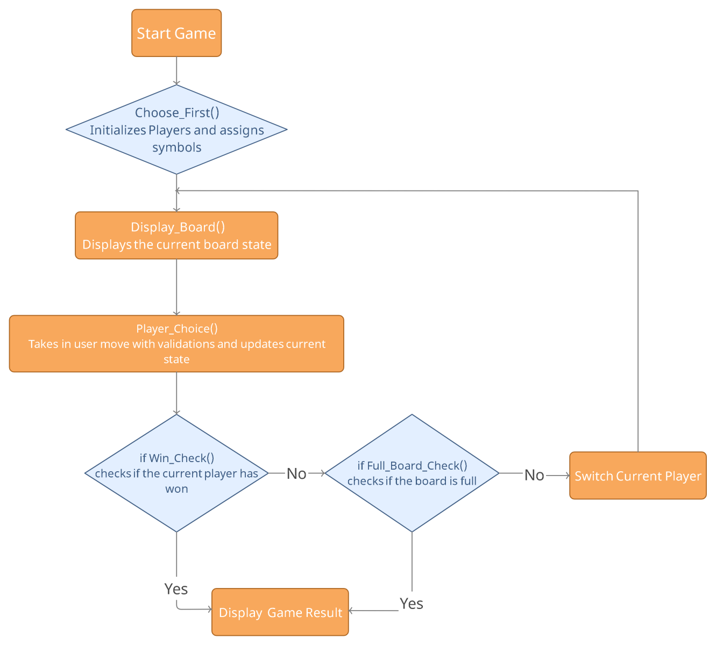

**CODE IMPLEMENTATION:**

1.In order to run this code we have imported “from IPython.display import clear_output”.

2.Run the complete code final_code_TicTacToe.ipynb.

3.After running the code following window will be displayed

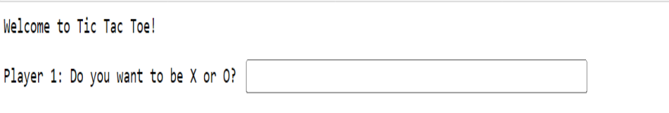

4.After completion , the message will be displayed on the screen with the winner name I.e. either ‘X’ or ‘O’ or draw game.